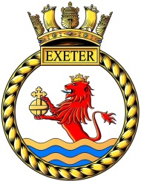
HMS Exeter Association
Monday 20th March 2017

Dear All,

Below are the details of the HMS Exeter Association, and all of its committee members.

Committee Members;
- Chair: Alan Leslie
- Vice Chair: Tom Jowett
- Treasurer: Paul Stone
- Secretary: Jessica Davis
- Membership Secretary: Shane Craven
- Merchandise & Slops Officer: Steve Kay
- Website Designer: Mick Murden
- CONA Representative: Paul Harvey-Hunter
- Committee Member: Grahame (Robbie) Robinson
- Committee Member: Dougie Leask
- Committee Member: Jamie Ditchburn
- Committee Member: Reg Cornell
- Macassar Representative, Committee Member: Jennifer Schofield
- Macassar Representative, Committee Member: Peter Cox
- Macassar Representative, Committee Member: Martin Horwell
- Macassar Representative, Committee Member: Tara Green
- Macassar Representative, Committee Member: Yvonne Birchell
- River Plate, Committee Member: Ray London
- River Plate, Committee Member: Liz Broughton

If anyone has any objections or suggestions towards their roles, or would like to support another member of the Committee in an aspect of a role, please do bring this to the attention of the Chairman of the Committee as soon as you are able to do so.

Kind regards

Jessica Davis
Association Secretary
HMS Exeter Association
Contact No: 07854971949

